**Final Project**

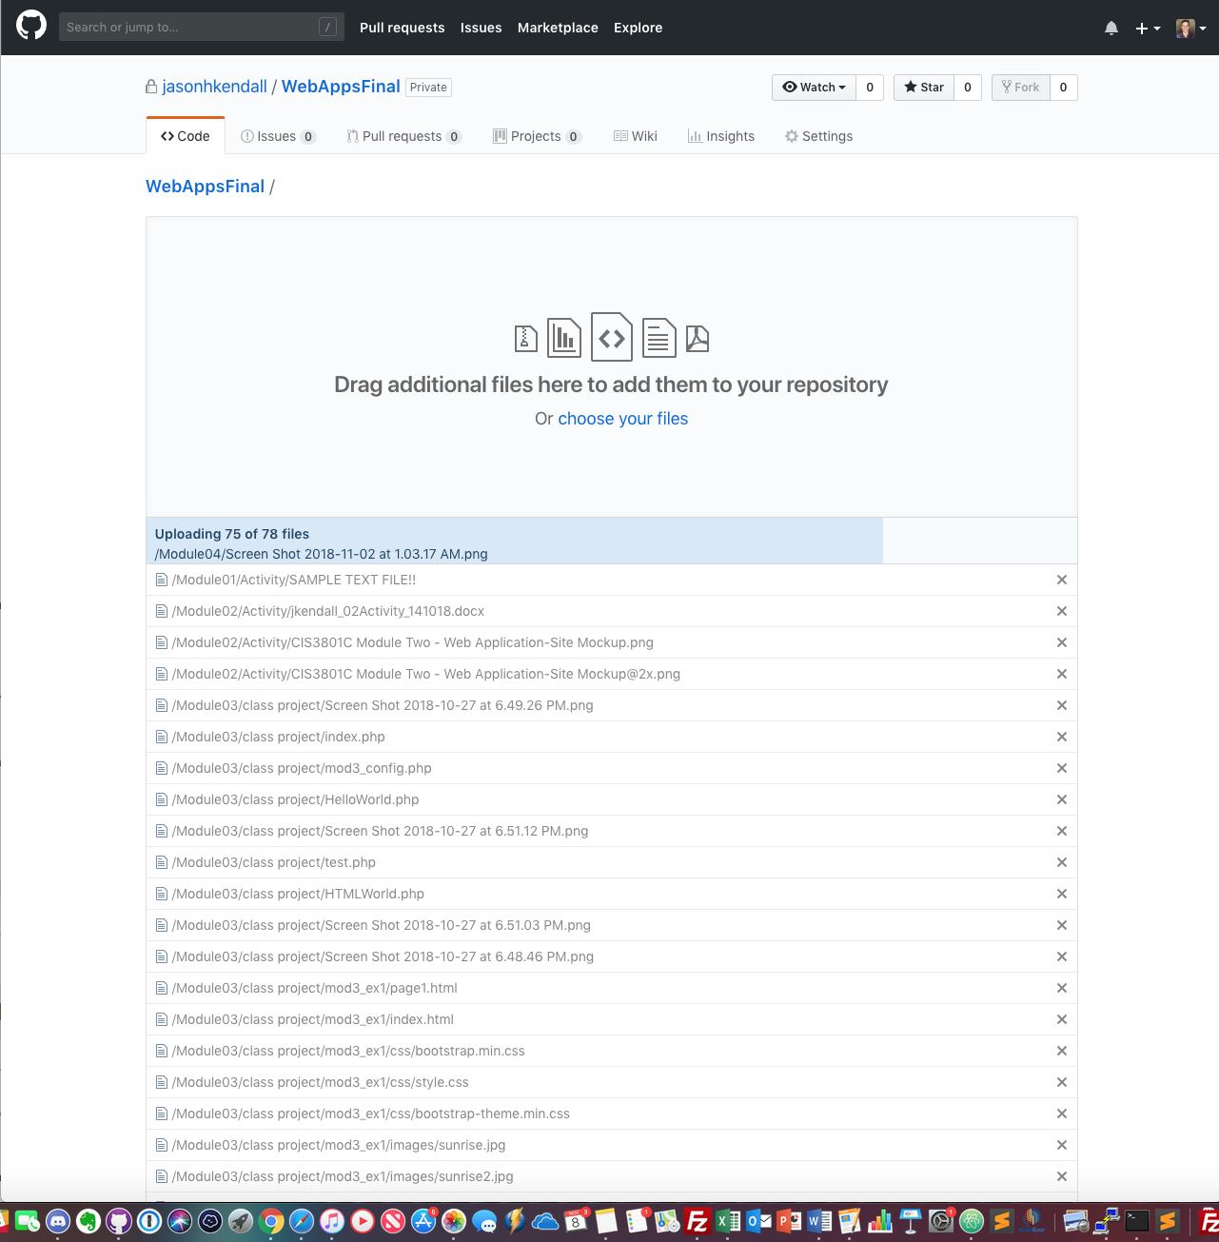

*Module 06 Project*

Jason Kendall

Fall 2018



GitHub URL:

https://github.com/jasonhkendall/WebAppsFinal